**Pre-requisite : Install sonar plugin under manage jenkins**

**Step 1 :** **in manage Jenkins ,goto > configure system**

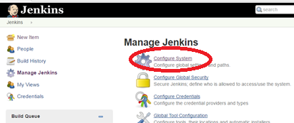

Step 2

YI : **The security token is generated from sonarqube server .Administrator > Account > Security**

**Login URL :** <http://54.91.53.200:9000/>

Username : admin

Password :admin

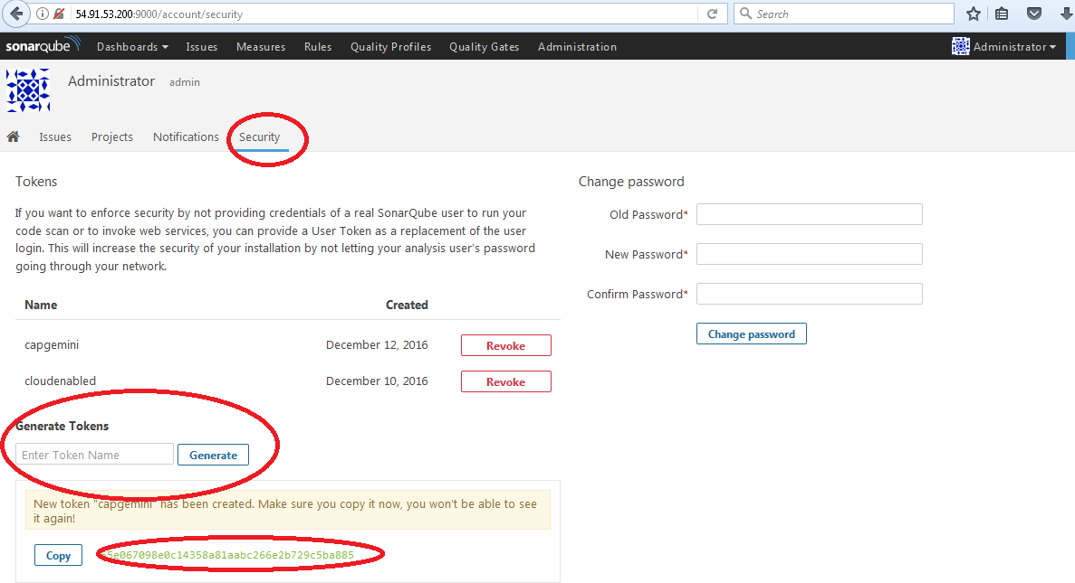

**Step 3.A :**  **Provide Sonarqube details**

**Name :** sonarqube

**Server url :** <http://54.91.53.200:9000/>

**Server authentication:** 55e067098e0c14358a81aabc266e2b729c5ba885

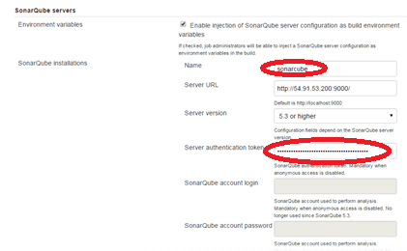

**Step 3:** **Go to configure of webapp-pipeline and add below pipeline script ( name should be same as sonarcube details you provided under manage Jenkins>configure system**

node ('node01') {

stage 'git clone'

git 'https://github.com/anilbidari/https-github.com-g0t4-jenkins2-course-spring-boot.git'

dir('spring-boot-samples/spring-boot-sample-web-static/')

{

stage ('SonarQube analysis')

withSonarQubeEnv('sonarqube') {

// requires SonarQube Scanner for Maven 3.2+

sh 'mvn org.sonarsource.scanner.maven:sonar-maven-plugin:3.2:sonar'

stage 'Approve'

input 'review sonar results and approve'

}

stage 'mvn package'

sh 'mvn clean package'

stage 'archive .jar file'

archiveArtifacts 'target/*.jar'

stage 'deploy on node01'

sh 'java -jar target/spring-boot-sample-web-static-1.4.0.BUILD-SNAPSHOT.jar'

}

}

}

**Step 4 :** **Click on build now**

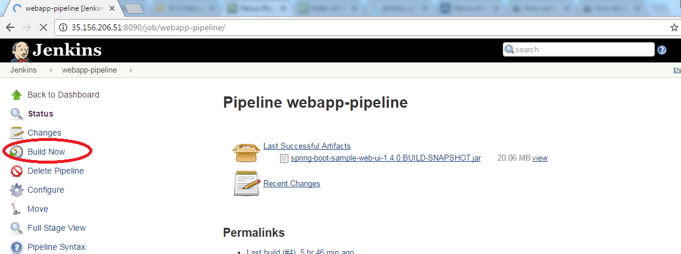

**Step 5 :** **Check stage sonarQube analysis**

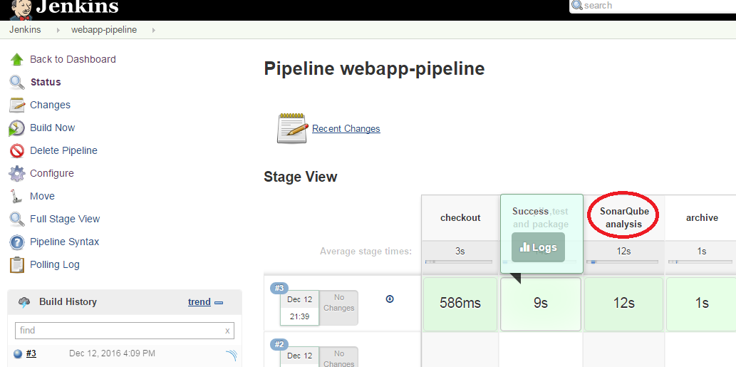

**Step 6 :** **Click on Logs for SonarQube analysis**

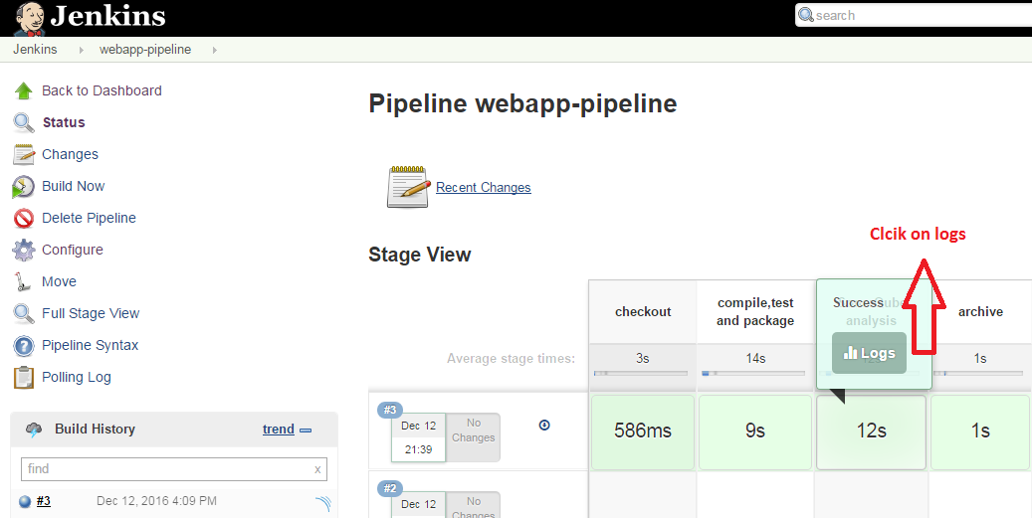

**Step 7 :** **Under logs click on below url**

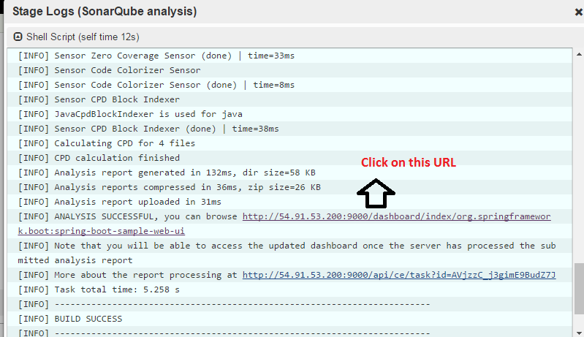

**Step 8 :** **Observe the code analysis**

